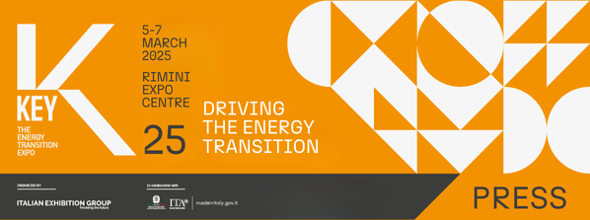

press release
(English translation)

PICHETTO FRATIN: AT KEY, THE DESIRE TO INNOVATE AND GAMBLE ON ENERGY TRANSITION AS A GROWTH DRIVER

- The Minister for the Environment and Energy Security today inaugurated Italian Exhibition Group’s event on the future of energy at Rimini Expo Centre. Also present were Maurizio Ermeti, President of IEG, Michele De Pascale, President of the Emilia-Romagna Region, Anna Montini, Rimini City Councillor for Ecological Transition, and Paolo Arrigoni, President of GSE

- Until 7th March at Rimini Expo Centre, over 1,000 exhibitors and about 350 hosted buyers and international delegations for the largest edition ever

Rimini (Italy), 5th March 2025 – KEY 2025 opens its doors and immediately displays “the vivacity, the desire to innovate and gamble on transition as a growth driver”, in the words of the Minister for the Environment and Energy Security, Gilberto Pichetto Fratin. As of today, and until Friday 7th March, Rimini Expo Centre will, in fact, be hosting KEY - The Energy Transition Expo, the IEG (Italian Exhibition Group) event of reference in Europe, Africa and the Mediterranean basin, dedicated to the future of energy.

Spread among the halls, over 1,000 exhibitors (20% more than in 2024), over 30% of which are international. Thanks to the support of the Ministry of Foreign Affairs and International Cooperation (MAECI), the Italian Trade Agency, collaboration with leading sector Associations, and a worldwide network of agents, about 350 hosted buyers and delegations from more than 50 countries will be attending the show, with North Africa, the Middle East, the Balkans and Eastern Europe the most represented areas.

THE OPENING CEREMONY
Under the Lorenzo Cagnoni Dome in the South Hall, the Opening Ceremony took place this morning with the Minister for the Environment and Energy Security, Gilberto Pichetto Fratin. After greetings from Maurizio Ermeti, President of Italian Exhibition Group, speakers included Michele De Pascale, President of the Emilia-Romagna Region, Anna Montini, Rimini City Councillor for Ecological Transition (Environment, Sustainable Development, Planning and Care of Public Green Areas), Blue Economy and Statistics, and Paolo Arrigoni, President of GSE.
Opening the event, IEG President, Maurizio Ermeti, described a global scenario “in which the World Energy Outlook reminds us that, by 2030, renewables and non-fossil sources will generate more than half of the world's electricity. Our country is proving to be virtuous because, already in 2024, renewables reached 41.2% of the national demand and are on their way to reaching the 2030 target of the Integrated National Plan for Energy and Climate, which sets the goal at around 60%. A virtuous country needs a virtuous trade show and KEY is exactly that show, enhancing a strategic sector with extraordinary repercussions on the economy and competitiveness. What makes this event unique is its approach, which does not focus on a single technology or sector, but tackles the issue of energy transition and efficiency in an integrated and all-round manner, focusing heavily on internationalisation, one of IEG's great objectives. So much so that today, while we are inaugurating KEY here in Rimini, at the same time we are also inaugurating a large edition of Ecomondo Mexico in Guadalajara.”
“Through the NPIEC, ” explained Gilberto Pichetto Fratin, Minister for the Environment and Energy Security, “Italy has embarked on a clear energy direction, oriented towards renewables and the pragmatism that is needed in the management of traditional sources. It is a route,” continued Pichetto, “that aims to open up to Italy, a keystone in the Mediterranean context, a range of potential for decarbonisation, including that of clean and sustainable nuclear power. The institutions are tasked with attentively accompanying our production fabric engaged in this challenge, which is both global and territorial. The KEY event,” the Minister concluded, “once again this year displays the vivacity, the desire to innovate and gamble on transition as a growth driver.”

For his part, the President of the Emilia-Romagna Region, Michele De Pascale, recalled how “Emilia-Romagna has always been a land of innovation and sustainability, values for which KEY - The Energy Transition Expo, is a showcase of excellence for the international debate on energy transition challenges, a reference point for companies, institutions and citizens committed to building a more sustainable future, fostering dialogue between research, industry and territories. Our region is at the forefront in promoting a development model capable of combining economic growth, environmental protection and social cohesion.”
And on the subject of the ecological transition, he added: “it is one of the great challenges of our time and for this reason, Emilia-Romagna intends to lead the way towards carbon neutrality before 2050 through a radical change of mentality and with the ambition of putting into play a realistic medium-to-long term strategy with clear objectives: security of supply and systems, cost competitiveness and the smallest possible carbon footprint by investing in renewables, energy efficiency and resilient infrastructure, areas in which our region is already a laboratory of innovation. We cannot afford delays: the energy transition must be concrete, fair and compatible with employment and the development of our production system.”

Anna Montini, Rimini City Councillor for Ecological Transition, underlined: “The diffusion and development of renewable energies and energy efficiency solutions are among the decisive challenges for the future of the planet and, although these are global issues, they necessarily require individual as well as collective awareness and responsibility. Cities and local institutions can also play an important role by becoming promoters of innovative growth models that can be environmentally, economically and socially sustainable.” Renewable energy communities, for example, go in this direction: “A model that Rimini has been working on for some time,” continued Montini, “and that can act as an example of a project in which environmental protection combines with technological progress and social equity. We believe that KEY, in addition to being a reference event for everything related to the energy transition, can be a valuable opportunity for companies and territories to discuss and exchange best practices and knowledge.”

Paolo Arrigoni, Presidente of GSE: “Rimini’s KEY is one of the most important events for strengthening dialogue between institutions, companies and industry stakeholders. The GSE is ready to provide tools, expertise and vision to make the energy transition not just a goal, but an opportunity for economic growth, a concrete and sustainable reality for all. In order to achieve these objectives, we are mainly acting along three lines: operability, through the management of more than 30 incentive tools to accelerate the spread of renewable energy sources, energy efficiency, sustainable mobility and Energy Communities; technical and operational support for companies, SMEs, both large and energy-intensive, and to PAs; digital innovation, through the implementation of advanced tools, such as the Interactive Map of Primary Cabins for RECs, the PUN (Single National Platform of public recharging infrastructures for electric mobility), the PAI (Platform of Eligible Areas for RES systems), and the NPIEC Monitoring Platform, which centralise and provide essential data for planning and implementing the country's energy policies.”

NUMEROUS NEW IDEAS AND CURIOSITIES AT THE SHOW
Confirmation of the driving force of this sector in representing the needs of the near future also comes from the many innovations on display in the halls. From coloured photovoltaic panels that can satisfy the most sophisticated aesthetic and architectural needs, to those made in Italy with maximum yield and minimum annual decay. From the most innovative solutions for exploiting renewable energy to make our homes increasingly sustainable to the National Sustainable Electric Cars Race for Students (SEL3C4RS), a project promoted and organised by the Network of Schools for Sustainable Mobility to cultivate a culture of sustainability and electric mobility in young students, enabling them to develop the technical and transversal skills that are fundamental for tackling their studies and preparing them for the world of work.

ABOUT KEY 2025
Event: International trade show; Organizer: Italian Exhibition Group S.p.A.; Frequency: annual; Edition: 3rd; Dates: 5-7 March 2025; mail keyenergy@iegexpo.it; Website: http://www.key-expo.com; Facebook: https://www.facebook.com/keyexpo/; Instagram: https://www.instagram.com/key_expo/; LinkedIn: https://www.linkedin.com/company/keyenergy/

PRESS CONTACT KEY - ITALIAN EXHIBITION GROUP
head of media & corporate communication: Elisabetta Vitali; press office manager: Marco Forcellini, Pier Francesco Bellini; international press office coordinator: Silvia Giorgi; press office coordinator: Luca Paganin; press office specialists: Nicoletta Evangelisti, Mirko Malgieri; media@iegexpo.it

MEDIA AGENCY: Smartitaly Communications
Sara Scatena, s.scatena@smartitaly.it, mob. +39 338 7836985; Arianna Geli, a.geli@smartitaly.it, mob. +39 347 0917903

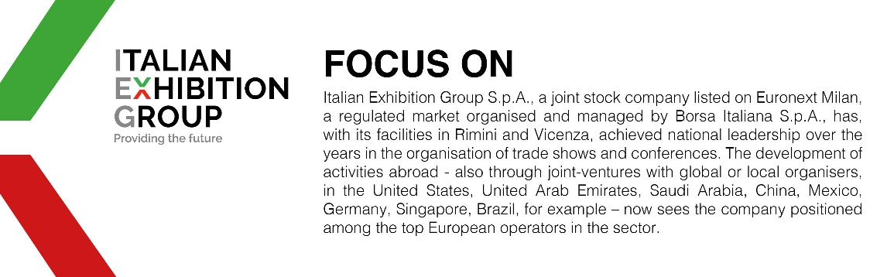

This press release contains forecast elements and estimates that reflect the management’s current opinions (“forward-looking statements”), particularly regarding future management performance, realization of investments, cash flow trends and the evolution of the financial structure. For their very nature, forward-looking statements have a component of risk and uncertainty, as they depend on the occurrence of future events. The effective results may differ (even significantly) from those announced, due to numerous factors, including, only by way of example: food service market and tourist flow trends in Italy, gold and jewellery market trends, green economy market trends; the evolution of raw material prices; general macroeconomic conditions; geopolitical factors and evolutions in the legislative framework. Moreover, the information contained in this release does not claim to be complete, and has not been verified by independent third parties. Forecasts, estimates and objectives contained herein are based on the information available to the Company as at the date of this release.

